John Michael Go
Career Entry Level Java Programming
Date: Jan. 16, 2013

DAY 4

Program Name: Assign 2 (JOption Pane)

Objective: Program will ask for 5 digits and will display how many positive, negative and zero numbers.

Algorithm:

- User inputs 5 numbers composed of positive, negative and zeroes.
- Program displays how many positive, negative and zero numbers entered.

Flowchart:
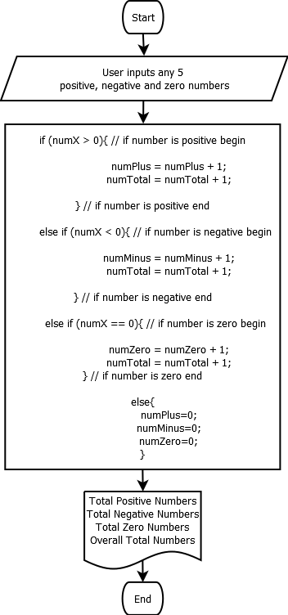

Pseudocode:

import javax.swing.JOptionPane;

public class Assign2{

public static void main(String[]args){
// variable declaration
int numX, numPlus=0, numMinus=0, numZero=0, numTotal=0;
String numStr;

numStr=JOptionPane.showInputDialog("Enter 1st number: "); // ask for the 1st input
numX=Integer.parseInt(numStr);

if (numX > 0){ // if number is positive begin

numPlus = numPlus + 1;
numTotal = numTotal + 1;

} // if number is positive end

else if (numX < 0){ // if number is negative begin

numMinus = numMinus + 1;
numTotal = numTotal + 1;

} // if number is negative end

else if (numX == 0){ // if number is zero begin

numZero = numZero + 1;
numTotal = numTotal + 1;
} // if number is zero end

else{
numPlus=0;
numMinus=0;
numZero=0;

}

numStr=JOptionPane.showInputDialog("Enter 2nd number: "); // ask for the 2nd input
numX=Integer.parseInt(numStr);

if (numX > 0){ // if number is positive begin

numPlus = numPlus + 1;
numTotal = numTotal + 1;

} // if number is positive end

else if (numX < 0){ // if number is negative begin

numMinus = numMinus + 1;
numTotal = numTotal + 1;

} // if number is negative end

else if (numX == 0){ // if number is zero begin

numZero = numZero + 1;
numTotal = numTotal + 1;
} // if number is zero end

else{

numPlus=0;
numMinus=0;
numZero=0;

}

numStr=JOptionPane.showInputDialog("Enter 3rd number: "); // ask for the 3rd input
numX=Integer.parseInt(numStr);

if (numX > 0){ // if number is positive begin

numPlus = numPlus + 1;
numTotal = numTotal + 1;

} // if number is positive end

else if (numX < 0){ // if number is negative begin

numMinus = numMinus + 1;
numTotal = numTotal + 1;

} // if number is negative end

else if (numX == 0){ // if number is zero begin

numZero = numZero + 1;
numTotal = numTotal + 1;
} // if number is zero end

else{

numPlus=0;
numMinus=0;
numZero=0;

}

numStr=JOptionPane.showInputDialog("Enter 4th number: "); // ask for the 4th input
numX=Integer.parseInt(numStr);

if (numX > 0){ // if number is positive begin

numPlus = numPlus + 1;
numTotal = numTotal + 1;

} // if number is positive end

else if (numX < 0){ // if number is negative begin

numMinus = numMinus + 1;
numTotal = numTotal + 1;

} // if number is negative end

else if (numX == 0){ // if number is zero begin

numZero = numZero + 1;
numTotal = numTotal + 1;
} // if number is zero end

else{

numPlus=0;
numMinus=0;
numZero=0;

}

numStr=JOptionPane.showInputDialog("Enter 5th number: "); // ask for the 5th input
numX=Integer.parseInt(numStr);

if (numX > 0){ // if number is positive begin

numPlus = numPlus + 1;
numTotal = numTotal + 1;

} // if number is positive end

else if (numX < 0){ // if number is negative begin

numMinus = numMinus + 1;
numTotal = numTotal + 1;

} // if number is negative end

else if (numX == 0){ // if number is zero begin

numZero = numZero + 1;
numTotal = numTotal + 1;
} // if number is zero end

else{

numPlus=0;
numMinus=0;
numZero=0;

}

JOptionPane.showMessageDialog(null,"Total Positive Numbers: " + numPlus + "\n"
+ "Total Negative Numbers: " + numMinus + "\n"
+ "Total Zero Numbers: " + numZero + "\n"
+ "Total Numbers: " + numTotal , "Total Numbers", JOptionPane.INFORMATION_MESSAGE);

System.exit(0);

} // public static void end

} // public class end

Screenshot:

